DIGESTIVE SYSTEM

Digestion:
- The breakdown of food into small soluble molecules
- Occurs physically, chemically

Absorption:
- The taking into the body of the specific compounds

Elimination:
- The expulsion of materials not absorbed (taken into) the body
- Excretion of wastes

LOCATIONS OF PARTS. Give a function(s) for each
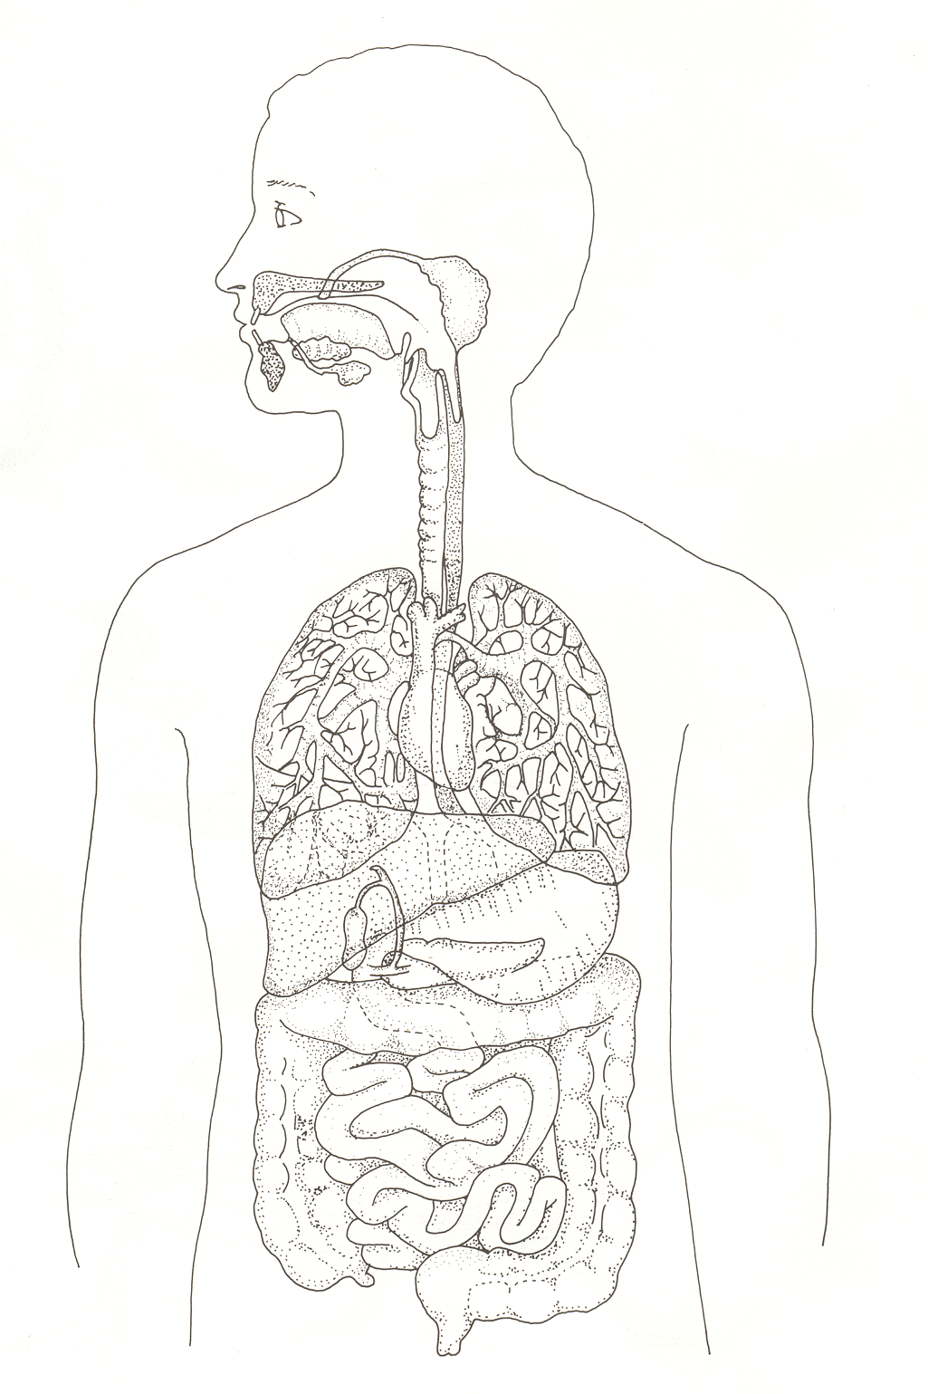
- oral cavity (mouth)
- pharynx
- tongue, teeth
- salivary glands (2)
- epiglottis
- esophagus
- stomach (2)
- cardiac sphincter
- duodenum
- pyloric sphincter
- small intestine (2)
- liver (digestive functions only)
- gall bladder
- pancreas (3)
- colon or large intestine (2)
- appendix
- rectum
- anus

DIGESTIVE ENZYMES
- These enzymes break down food (polymers) into small molecules (monomers)

Salivary Amylase:
Source: Salivary glands
pH: Neutral
Food digested: Starch
Product: Maltose (a disaccharide)

Pepsinogen:
Source: Stomach
pH: Acidic (pH 2.5)
Food Digested: None
Product: Becomes the Enzyme Pepsin
Pepsin:
Source: Stomach
pH: Acidic (pH 2.5)
Food Digested: Protein
Product: Peptides (short amino acid chains)
Note: Secreted as Pepsinogen, an inactive form. A low (acidic) pH converts pepsinogen into the active pepsin

Pancreatic Amylase:
Source: Pancreas
pH: Basic (pH 8.5)
Food Digested: Starch
Product: Maltose

Trypsin:
Source: Pancreas
pH: Basic (pH 8.5)
Food Digested: Peptides (Digested from Pepsin in stomach)
Product: Smaller Peptides (short amino acid chains)
Lipase:
Source: Pancreas
pH: Basic (pH 8.5)
Food Digested: Fat
Product: Glycerol, Fatty Acids

Peptidases: (many different ones)
Source: Small intestine
pH: Basic (pH 8.5)
Food Digested: Peptides
Product: Amino Acids

Maltase:
Source: Small intestine
pH: Basic (pH 8.5)
Food Digested: Maltose
Product: Glucose

Nuclease:
Source: Small intestine and Pancreas
pH: Basic (pH 8.5)
Food Digested: Nucleic Acid (DNA & RNA)
Product: Nucleotides (A,C,G,T & U)

Enzyme Digestion in the Human Digestive System
 | Carbohydrate Digestion | Protein | Digestion | Fat Digestion
Oral Cavity
(pH 7.0)
Stomach
(pH 2.5)
Small Intestine
(Pancreas)
(pH 8.5)
Small
Intestine
(pH 8.5)

FILL IN THE ABOVE TABLE USING THE TERMS BELOW

(Salivary Amylase) (peptidases) (Bile *not an enzyme*)
Starch Maltose Small peptides Amino Acids Fat globule Emulsified fat

(Pancreatic amylase) (Lipase) (Pepsin)
Starch Maltose Fats Glycerol and Fatty acids Protein Polypeptides

(Trypsin) (Maltase, Sucrase, Lactase etc.)
Polypeptides Smaller polypeptides Disaccharides Monosaccharides
SWALLOWING AND PERISTALSIS

- Swallowing involves the formation of a bolus (food ball) which is formed by the mouth, teeth, tongue, and saliva from the salivary glands
- When swallowing, the esophagus moves the bolus into the stomach by peristalsis
- Peristalsis is a rhythmic contraction of the esophagus and intestine
- Muscle contractions (smooth muscle) run along the tube and push food material in one direction

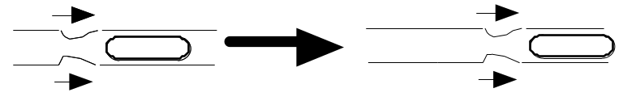
Peristalsis

GASTRIC, PANCREATIC, AND INTESTINAL JUICES

Salivary Glands:
- Saliva: H2O, mucus
- Lubrication of food
- Formation of a bolus (food ball)
- salivary amylase → starch digestion

Stomach: - Gastric juice
- Water (for hydrolysis)
- Pepsinogen (inactive form of the enzyme Pepsin) – secreted by chief cells
- HCl (Hydrochloric acid) – secreted by parietal cells
- Lowers pH
- To activate Pepsin which digests large proteins to small amino acid chains
(peptides)
- Food becomes semi liquid mass called acid chyme
- Kills bacteria on food

Pancreas: - Pancreatic juice
- Pancreatic juice enters into the duodenum
- Sodium Bicarbonate: (Baking Soda)
- Very important in neutralizing stomach acid to give a slightly basic pH in intestine. (pH 2.5 in stomach to pH 8.5 in intestine)
- Enzymes:
- Pancreatic Amylase
- Trypsin
- Lipase
- Nuclease (digests DNA & RNA to nucleotides)
Small intestine (including duodenum)
- Enzymes
- Maltase
- Peptidases
- Nucleases

Accessory glands (food does not directly pass through them)

Pancreas:

INSULIN (and Glucagon)

The hormone Insulin is produced by cells in the Pancreas called islets of Langerhans. Insulin acts upon the cell membranes of most cells and opens the protein gates in the membranes, allowing glucose to enter the cells from the blood. This has the effect of lowering blood sugar. Insulin also stimulates the liver and muscles to convert glucose to glycogen, as well as promoting the formation of fats and proteins.
A second hormone produced by the same cells called Glucagon does just the opposite of insulin, so will increase blood glucose levels.

Liver:
BILE
The liver is connected to the intestines (villi) by the Hepatic portal vein which carries blood rich in foods to the liver. The liver acts as the gatekeeper to the blood by keeping levels of various foods constant.

An important digestive function of the Liver
- Secretes bile, which is stored in the gall bladder- green fluid
- Breakdown fluid of hemoglobin
- Emulsifies fats
- Breaks fat drops into tiny droplets which are homogeneous
- Stay in suspension
- Increases surface area of the fat droplets for Lipase to work on

THE 6 FUNCTIONS OF THE LIVER:

- It removes poisonous substances (detoxifies blood)
- Stores glucose in the form of Glycogen. Converts glycogen to glucose when blood sugar levels drop.
- Destroys old red blood cells - (converts hemoglobin to bile)
- Produces urea from breakdown product of amino acids
- Urea: nitrogenous waste
- Makes blood proteins
- Converts amino acids to glucose if necessary
- “Gluconeogenesis”

SMALL INTESTINE

- 6 meters in length
- First 15cm is called Duodenum
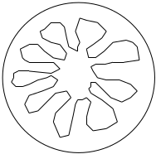
- Produces digestive enzymes
- lactase, peptidases, maltase, nucleases
- Most important function: Absorption
- Structure:
- Walls highly convoluted - to increase surface area
- Covered with villi
- Tiny fingerlike projections
- Gives small intestine large surface area
- Each villi is cover in microvilli which further increase surface area

- Villi:

(Fig. 9.9 p. 189)

- absorption takes place through the columnar cells. This involves active transport and requires much energy.
- sugar and amino acids are absorbed by the capillaries
- glycerol and fatty acids absorbed by the lymph lacteals

E. coli AND THE LARGE INTESTINE

- includes the colon and rectum

Colon
- reabsorption of water and some salts
- 4/5 of large intestine
- also has a large population of E. coli bacteria which digest some indigestible material and produce:
a) gas (flatulence)
b) amino acids
c) vitamins
d) growth factors (proteins that stimulate cell growth)

Assignment

READ CHAPTER 9, P. 181-196
Objective Questions P.205

Written Questions

- List seven substances secreted by the pancreas, and give a specific function for each. (7 marks)
- Discuss how proteins, fats and carbohydrates are absorbed by the small intestine. (3 marks)
- Describe how a carbohydrate is chemically digested. This should include all enzymes reactions, where they are made and where they act that are involved in the digestion of carbohydrates (e.g. starch). (6 marks)
- Describe how a protein is chemically digested. This should include all hormones, enzyme reactions, where they are made and where they act that are involved in the digestion of proteins. (7 marks)
- Describe how a fat is chemically digested. This should include all steps, enzymes/substances/hormones and organs involved in the digestion of fats. (6 marks)
- What are the functions of sodium bicarbonate and hydrochloric acid in the digestive system? Where do they come from? (4 marks)
- Why is there mucus in gastric juice? (1 mark)

