PROTEIN SYNTHESIS

DNA mRNA PROTEIN
TRANSCRIPTION TRANSLATION

i) Transcription – DNA mRNA

1. DNA unzips (as in replication) but only at a specified spot (a gene).
- Only a portion of the DNA unzips

2. RNA is transcribed (copied from the DNA in the nucleus)
-Uracil (U) replaces Thymine (T)
-RNA nucleotides match up with their complementary DNA bases.
- Only 1 side of DNA is used
- Called Messenger RNA (mRNA)

(Note: There are 3 kinds of RNA transcribed in the nucleus; Messenger, Transfer and Ribosomal. Transfer and Ribosomal are stable, and reused so it is mostly mRNA that is being continuously transcribed)

3. The mRNA then moves out through the nuclear pores into the cytoplasm where it is translated into an amino acid sequence.

TRANSCRIPTION

ii) Translation (mRNA to Protein)

- Occurs with ribosomes
-Small organelles composed of protein and rRNA (ribosomal RNA is transcribed
in the nucleus in the Nucleolus)

Mr. Ribosome

- Ribosomes are usually found on the surface of the endoplasmic reticulum (ER) or in groups (polysomes) free floating in the cytoplasm.
- They are the site of protein synthesis (Translation)

Transfer RNA - tRNA

- carries the specific amino acid to its coded spot (codon) on the mRNA
- has an anticodon which matches the mRNA (ie: has complementary bases)

Amino acid

tRNA

Anticodon
U G A

A C U G C C A A C mRNA

Codons

The Code - codons
- The codon is a three base unit of the mRNA
- Each codon calls for a specific amino acid

CODON AMINO ACID
CCU Proline
UUA Leucine Genetic Code
UAA STOP - end of chain

This code is universal - the same for all living things

Finally…The Actual Process

INITIATION:

- Ribosome lines up with the messenger RNA at the start (AUG) codon
- A transfer RNA with the proper (complementary) anticodon and its correct amino acid line up on the codon of the mRNA
- The ribosome moves along the mRNA the space of one codon
- A second tRNA with its correct amino acid lines up on the second codon
- The ribosome checks the codon / anticodons for a correct matches and then catalyses a peptide bond between the two amino acids on top of the tRNAs.
- The ribosome moves along the mRNA the space of one codon

ELONGATION:

- Ribosomes move along messenger RNA reading codons and binding amino acids that are in the right place due to the transfer RNA (tRNA).
- Enzyme on ribosome catalyses the peptide bond
- Chain grows one amino acid at a time

TERMINATION:

- Ribosome reads “terminate” codon (UAG) and stops
- Releases protein which will fold into secondary, tertiary shape
- Process takes seconds up to 3 minutes
- Several ribosomes may run down it at one time
- mRNA disintegrates after translation is complete (some forms last longer than others, usually flagged with a total of sev. hundred Adenine bases)

Assignment

1. Sketch the process of Protein Synthesis (Ex. p. 489) – ensure to show the location of each step.
2. Do Amino acid sequence exercise
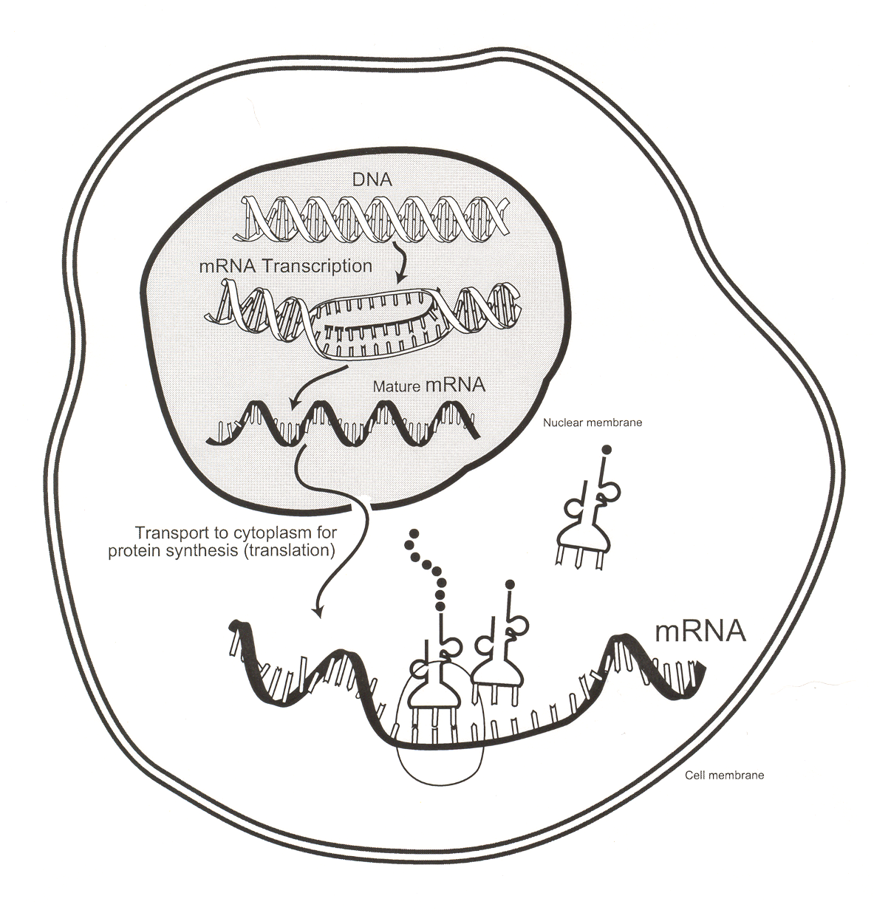
Protein Synthesis
ACAGUUGCAUGAC
ACA GUU GCA UGA C
UGU CAA CGU ACU G
D) Threonine, Valine, Alanine, Stop
E) Threonine, Valine Cystiene Methionine (or start)
F) Threonine Leucine Histidine Aspartate
G) Threonine, Valine, Alanine Stop
DETERMINING AMINO ACID SEQUENCES FROM DNA CODE

Given the following DNA nucleotide sequence:

2 1 3

TGTCAACGTACTG

A) Give the mRNA sequence that would be transcribed from it.

B) Give the mRNA codons.

C) Give the tRNA anticodons.

D) Give the amino acid sequence that would be translated from it.

E) A mutation has inserted a G in between the two A’s (1). Give the new amino acid sequence. (an addition)

F) A mutation has removed the 2nd T (2). Give the new amino acid sequence. (a deletion)

G) A mutation has changed the 3rd T to a C (3). Give the new amino acid
sequence. (a substitution)

H) Give any strand of DNA that would code for the following amino acids
Proline, Aspartate, Glutamate, Histidine
GGA CTA CTT GTA
GGC CTG CTC GTG
GGG
GGT

MUTATIONS AND DEFECTS

Chromosome Mutation:
- A change in the physical piecing of a chromosome
- Usually involves thousands of genes
- missing pieces
- extra pieces
- exchange of pieces

Translocation: Pieces of separate chromosomes are exchanged
Deletion: Pieces become missing
Duplication: Extra pieces are copied and added
Inversion: Pieces are flipped into reverse order

Gene
- A gene is the segment of DNA on a chromosome that codes for one protein.
- The human genome (all the DNA in all 46 chromosomes in one human cell) is aprox. 3 billion base pairs. Only 10 - 15 % of this DNA is actual genes.
- Haemophilus influenzae , the first organism (a bacteria) that has had its entire genome worked out (each base!) is 1.8 million bases long.

Gene Mutation:
- A change in the nucleotide sequence
- Only one gene is affected
Deletion: One base is left out
- serious
- change all of the codons following it
Frame shift
Addition: One base is added Mutations
- serious
- change all the codons following it

Substitution: Pieces are replaced with each other.
- less serious Point mutation
- only one codon is affected.

Deletion

Addition

Substitution

Causes of Mutations:

Germinal
- Can be passed on to offspring (Ex.hemophilia)
Somatic Mutation
- Body cell
- Not inheritable
- Responsible for many cancers
X-rays, Radiation, Chemicals etc. can all be mutagens

Mutations and Genetic Disorders

- normally, chemical reactions occur in “pathways”

A B C D CLOT

ENZYME AB ENZYME BC ENZYME CD

- If Enzyme BC were mutated and nonfunctional, then compounds C and D could not be made. Clot would not form - Hemophilia
- This is an abnormal body function, or disease.

Assignment

- Describe the steps and location of transcription.
- Describe the steps and location of translation.
- Name the three kinds of point mutations. Which ones are most potentially dangerous to a cell and why?
- Find a CURRENT and SPECIFIC example of how recombinant DNA can be used. Feel free to use the internet – just cite the website!!!

