Capillary Tissue Fluid Exchange
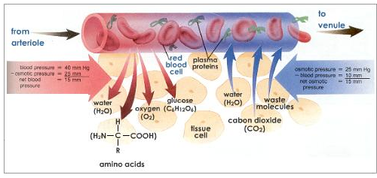
https://www.youtube.com/watch?v=Q530H1WxtOw
Simplified Description

My Capillary Tissue Fluid Exchange

