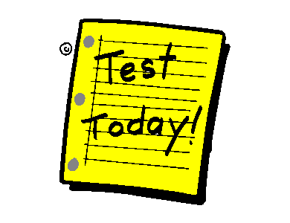
Final Exam Outline
Biology 11

Date: __________________ Time: ________ Room____

As discussed in class, the Biology 11 exam will include material from the whole semester. However, it will be more heavily weighted on the second term.

To narrow the focus of your studying I have compiled the following list which outlines the topics you will be expected to know for your test.

TERM 1 – General Biology, Evolution, Microbiology
- Scientific Method
- Six Majors Themes in Biology
- Levels of Organization
- Characteristics & Activities of Living Things
- 6 Kingdom Approach
- DNA versus RNA
- Hardy-Weinberg Principle
- Natural Selection
- Convergent versus Divergent Evolution
- Distinguishing characteristics of viruses, bacteria, protists and fungi
- Viruses: Living or Nonliving?
- Prokaryotes versus Eukaryotes
- Ecology: pyramid of energy

TERM 2 – Animals and Plants
(1) Kingdom Plantae
- Distinguishing features of this kingdom
- Vascular versus non-vascular plants
- Plant Life Cycles
- Monocot versus dicot
- Flower structure
- Evolution of plants to live in a terrestrial environment
- Know distinguishing characteristics of each of the following groups:
Algae, Bryophytes, Ferns, Gymnosperms, Angiosperms

(2) Kingdom Animalia
- Distinguishing features of this kingdom
- Invertebrates versus vertebrates
- Characteristics of a successful parasite
- Arthropod/Vertebrate adaptations to terrestrial life
- Exoskeleton versus endoskeleton
- Know the general structure & organ systems of the following phyla:
Porifera, Cnidarians, Platyhelminthes, Nematodes, Annelids
Molluscs, Echinoderms, Arthropods, & Chordata (fish, amphibians, reptiles,
birds, mammals)

Format
- The test format will be similar to the section tests.
- You can expect to see a multiple choice section, matching section, diagrams of representative organisms and short answer questions.
Study Tips
- Do not wait until the last minute
- You will have all of your tests since the beginning of the semester – in addition to your notes, worksheets, study guide. Study these – you may see some questions again!
- There will be a few days for review at the end of the course – this is a good time to ask me questions.
- If you need additional help please DO NOT HESITATE to come see me! I will be in the school throughout the week before the exam.

Required Materials
- Writing Utensils
- Study Guide


