Plant Test Outline

1. General Characteristics of the Plant Kingdom
   1. Plant Cell Parts
   2. Photosynthesis Equation
   3. Eukaryotic, Autotrophic, Producers
   4. Haploid, Diploid, Gametophyte, Sporophyte
2. Algae (Chlorophyta, Rhodophyta, Phaeophyta)
   1. General Characteristics of each phyla (Red, Green, Brown)
   2. Body Structures (blade, stipe, holdfasts, floats)
3. Mosses & Liverworts
   1. General Characteristics
   2. Life Cycle
   3. How they are adapted to live on land
4. Vascular Plants (Tracheophyta)
   1. Adaptations to Live on Land: Vascular Tissue, Cuticle, Leaves, Roots, Reproduction without Water
   2. Seedless Vascular Plants
      1. Ferns – Body Plan, Life Cycle
      2. Horsetails, Whisk Ferns, Club Mosses (know common & scientific names)
   3. Gymnosperms
      1. Cycads, Ginkgo, Conifer, Gnetophyte (recognize this groups using diagrams)
      2. Conifers – General Characteristics, Body Plan, Life Cycle
   4. Angiosperms
      1. General Characteristics
      2. Flower Structures and Functions
      3. Fruit and Seed Dispersal
      4. Monocots versus Dicots
   5. Fertilization and Pollination
   6. 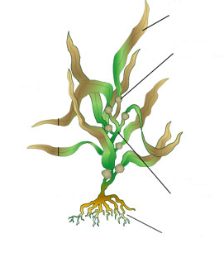Xylem and Phloem



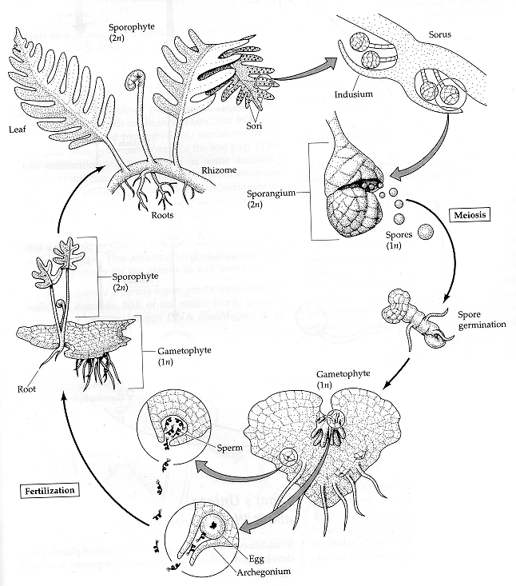

[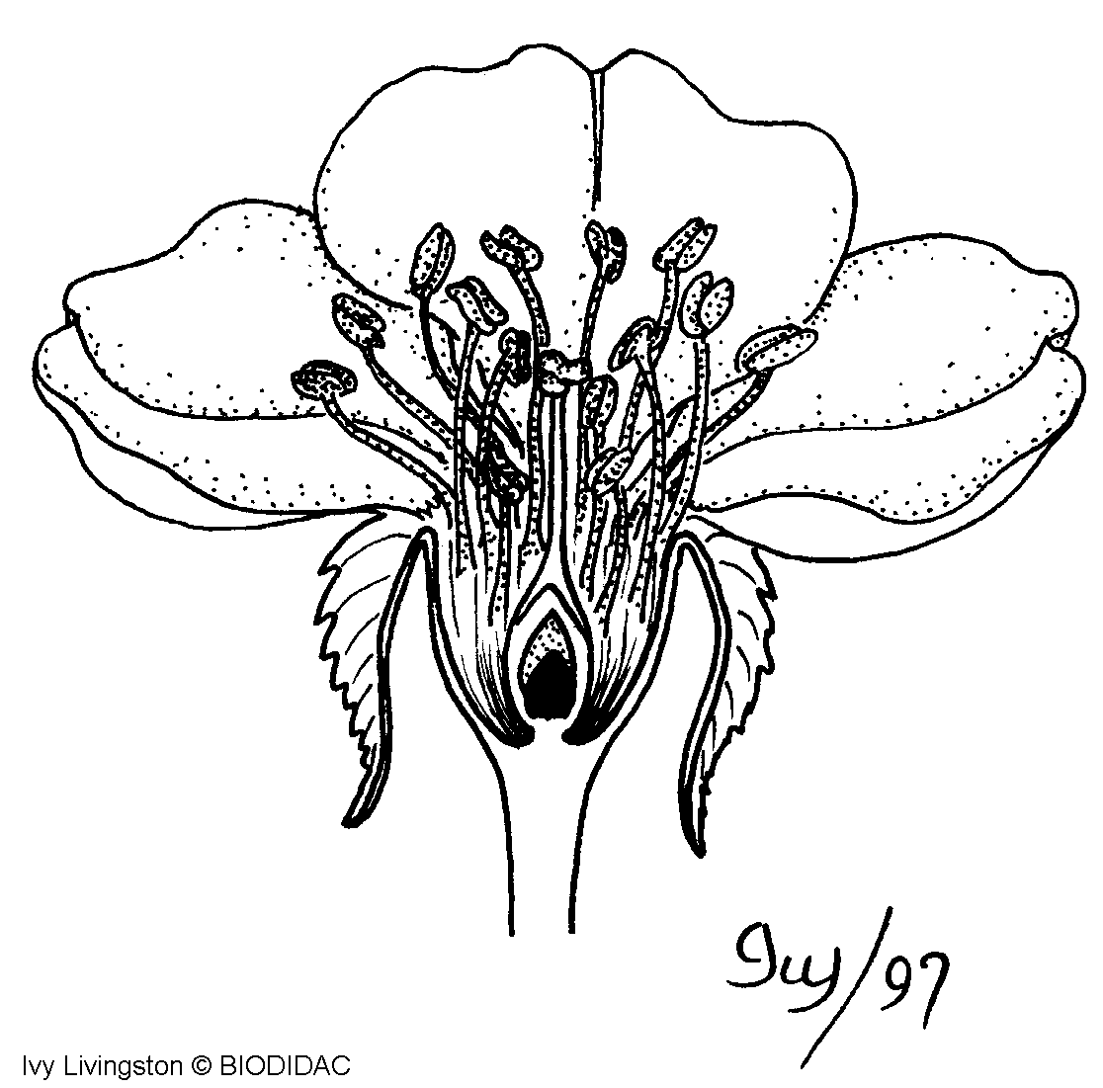](http://biodidac.bio.uottawa.ca/Thumbnails/showimage.cfm?File_name=DICO006B&File_type=GIF)



