The Role of Kinetic Energy in Physical Changes
Name: _______________________________
- Kinetic Energy: ______________________________________________________________

- There are three types of kinetic energy a molecule can possess:
  - Rotational: ____________________________________________________________

  - Vibrational: ____________________________________________________________

  - Translational:____________________________________________________________

- Practical Applications of Kinetic Energy
  - Microwave Ovens
  - Infrared Spectroscopy – infrared light is shone through a chemical sample and some of the infrared light is absorbed by the sample. The frequency of the infrared light is slowly changed and a detector plots how much energy the sample absorbs. Each chemical has a resulting “fingerprint.” The graph below shows an IR spectrum for ethanol.

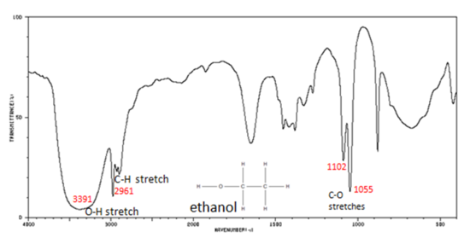

- The Role of Kinetic Energy in Phase Changes
  - Review the graph on page 64. What do you notice about translational energy as a substance moves from solid to liquid to gas?
________________________________________________________________________

- Complete questions #64-71 on page 64.

